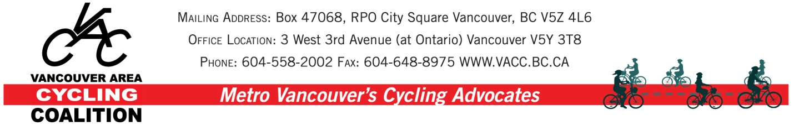

December 1st, 2011

Dear Mayor and Council,

On behalf of the Vancouver Area Cycling Coalition (VACC) Vancouver/UBC Committee, we would like to address the issue of the need for appropriate accommodation, detours and construction policy on bicycle routes, especially those which are heavily used. In order to illustrate the type of scenario that cyclists face at this time with no construction policy in place, we would like to draw your attention to a long-term break in the False Creek seawall where it passes by Granville Island on the south side of False Creek caused by a construction project.

A brief history of the seawall closure:
- the seawall was closed to pedestrian and cyclist traffic many months ago, including the whole busy summer period. Apparently the original stated period for the work to be done was October 2010- June 2011
- the detour that was given was very poor- both cyclists and pedestrians rerouted (cyclists supposedly walking) well out of the way of the path (heading west in this instance) right by the children's water park and the narrow path by the Children's Market. At that point, cyclists continuing along the seawall were expected to cycle along the very busy and narrow laned road out of Granville Island to rejoin the path or to walk their bikes a further distance on the sidewalk.
- way finding was very poor, leaving people on bike and foot unsure where to go to reconnect with the seawall.
- the signage stated that the work would be completed by June 2011.
- in late July, Lisa Slakov sent an email to the bike hotline and the parks board requesting an updated finish date and a better detour. She didn't receive a response although a couple of days later the end date was removed from the signage. She sent another email to the City in early October and received a response stating that David Lewis, Bicycle Coordinator, was looking into it.
- David discovered that, aside from a lengthy delay to the work caused by a construction problem early on of which he was aware, the contractors had not been working much on the project for some time because of problems with being paid by the City.
- David has been working to help resolve these issues and was told a few weeks ago by the contractors that the seawall would be reopened enough to allow pedestrians and cyclists to pass through. This opening has finally been created in the last couple of days, after approximately a year with no through traffic for cyclists and pedestrians.
It is very clear in this case that the city's highest priority modes of transportation are not considered a priority.

Consequently, we would like to see a policy in place whereby construction or other disruption on bicycle routes is required to be mitigated by very good detouring provisions with excellent signage. In addition, especially on busy bike routes, construction should be monitored so that it happens as quickly as possible.

We look forward to getting a response to our request for a bike route construction policy.

Sincerely,

Lisa Slakov
Co-chair, VACC Vancouver/UBC Committee

Heather Harvey
Co-Chair, VACC Vancouver/UBC Committee

