February 7, 2014
Erin Moxon
Senior Project Manager
Ministry of Transportation and Infrastructure
310 - 1500 Woolridge
Coquitlam BC V3K0B8
Erin.Moxon@gov.bc.ca

Cc: Vancouver Board of Parks and Recreation
Malcolm Bromley, General Manager, Vancouver Board of Parks and Recreation
Dale Bracewell, Manager, Active Transportation, City of Vancouver
Active Transportation Policy Council, City of Vancouver

Stanley Park Causeway Cycling and Walking Safety Improvements

Dear Ms. Moxon,
HUB is very pleased that the Ministry of Transportation and Infrastructure (MoTI) is moving forward with the planning of safety improvements to the pedestrian and cycling paths along the Stanley Park Causeway. We appreciate being consulted at an early phase of the design process and would like to take this opportunity to provide feedback on the draft design proposal presented to us in January which is titled “preliminary cross-section option for Causeway improvements”.

After reviewing the Ministry of Transportation and Infrastructure’s preliminary cross-section option for Causeway improvements, HUB is very concerned that the plans for the west side are not safe for the volume and speed of bicycle traffic both now and in the future nor is the proposal to ban pedestrians feasible as it will most likely be ignored. The plans for the east side in general are safer due to lower cyclist speed and greater width and can likely be improved further with our recommendations below.

HUB supports the addition of separation between people on bike/foot and motor vehicles. This is the highest priority improvement as it will prevent active transportation users from falling into fast moving traffic with serious or fatal injuries as a result. The separation can include either a concrete or grass buffer or a fence. Details to refine separation proposal are found in the specific recommendations below.

HUB supports the widening of the cycling and walking paths. This is a very high priority to prevent conflict for active transportation users and increase safety. This will also enable cyclists of all ages and abilities to safely share the path. While we recognize there are geographic, environmental, cultural and cost challenges to achieving this in some sections, due to the high speed of downhill cyclists, it is critical that improvements be made that ensure safe cycling and walking facilities on the west side.

Separate cycle and pedestrian paths with adequate widths for each is the ideal, but we understand the limitations with this project currently. Our vision is that of adequately wide cycling and walking paths on both sides of the Causeway suitable for the speed of cyclists on that side and volumes of cyclists and pedestrians both now and in the future.

- West Side
The west side sidewalk needs to be designed to safely accommodate high-speed cycling and shared walking and cycling for current and future demand. The proposed cross section is inadequate due to substandard width and lack of safe shy distance from obstacles leaving too little room for error or to recover from sliding on debris or ice or a collision with a pedestrian, pet or other cyclist. The obstacles (light posts, gantry poles, trees, etc.) pose a serious risk of injury or death should a cyclist hit them.

  - West Side - General Recommendations
    - Design the west side as a shared path for cyclists and pedestrians - The full and explicit ban of pedestrians on the west side is unlikely to work and may actually increase user conflict thus the path should be built wide enough to safely accommodate cyclists and pedestrians. Explicitly banning pedestrians here may also make the plan unacceptable to the public.
    - Path width - The path should be at least 3.0m with 0.6m shy distance from fencing and 1.0m shy distance from obstacles. The path needs to be wide enough to allow cyclists to pass pedestrians and slower cyclists. Where widening is not possible along the causeway, we recommend encouraging pedestrians to use alternative routes, by adding or improving routes and adding good wayfinding.
    - Fencing - Due to space constraints on the west side, fencing will likely be required to prevent cyclists from falling onto the roadway. See details on fencing below.
    - Turnout bays - Where space for new path construction is constrained, remove the bays. If this is not possible, improve alignment of path around motor vehicle pull-out bays. The current sidewalk alignment around the bays is challenging and potentially dangerous at downhill cycling speeds. Paths should be straightened somewhat in order to avoid the sharp curves around the pull-out bays, especially on the west side path.

  - West Side - Park Drive to Lake Trail Overpass
This is the section that requires the most improvement and is where the fatality in May 2013 occurred. The steep downhill slope (up to almost 7%) results in cycling speeds reaching 50km/h or more, thus the design speed of the new path in this section should be at least 50km/h.
    - Widen path - Widen the path to at least 3.0m (3.5m where possible) with a minimum 0.6m shy distance from fencing and a minimum 1.0m shy distance from unfenced obstacles.
    - Move obstacles - Move all the light poles and consider moving some of the gantry poles.
    - Fencing - Place a fence between the roadway and the path. See below for fencing recommendations.
    - Fence off obstacles - Where the gantry poles are not moved and a minimum 1.0m shy distance is not possible, smooth fencing should be used to prevent high-impact collisions with the poles.
    - New path through the park - In addition to the above improvements along the Causeway, we strongly recommend that MoTI work with Vancouver Park Board to create a new path of between 400m to 450m in the Park, This 3.5m wide shared path from south of Park Drive to Bridle Trail just north of Thompson would reduce demand for the path along the Causeway reducing conflicts and thus the risk of collision. It likely could also be made wheelchair accessible. If done immediately, it would provide a safe detour route during construction along the Causeway decreasing dramatically the likelihood of very dangerous two-way cycling along the east sidewalk. A portion of this new path could be built on an existing old road or path right-of-way. The terrain in this part of the park is not that challenging so a trail should be possible without major impacts on the park or loss of trees. This trail should be built to a high standard to attract a significant portion of bicycle and pedestrian traffic from the Causeway.

  - West Side - Lake Trail Overpass to Lagoon Drive
On this section, there are several trees and many poles too close to the sidewalk to allow the sidewalk to be widened enough to make it a safe cycling and walking path for current and future demand.
    - Widening - widen path along Causeway where possible without removing trees, even if path width varies.
    - Fencing - Place fence between the path and the roadway.
    - Upgrade existing trails in the park for walking and cycling - Bridle Trail and Tatlow Walk parallel the Causeway south of the overpass. Ideally, the paths would be lit and paved to encourage as many people as possible to use it instead of the substandard path along the Causeway. One of the two lanes of Lagoon Drive would need to be reallocated for walking and cycling to connect back to the Causeway.

  - West Side - Lions Gate Bridge to Park Drive
    - Remove obstacles - There are several obstacles near the path coming off the Bridge including light poles and signs that should be moved.
    - Fencing - Place fence between the path and the roadway.

  - Prospect Point Access Path
Create a separated bike path on the first southbound causeway exit south of Lions Gate Bridge to Park Drive to allow people walking and cycling to safely access Prospect Point and Park Drive.

  - Fencing Design
Fencing is a major safety improvement that will prevent cyclists from falling onto the roadway. However, care needs to be taken with the design and placement of the fencing so it does not increase other hazards.
    - Smooth surface - The fencing should have a smooth surface and not have any poles or protrusions that could cause a cyclist to crash or that could result in a secondary collision when a cyclist is falling or out of control as a result of a collision with a pole or pedestrian or slipping on ice or debris.
    - Fencing starts - The start of the fencing should be placed such that cyclists are unlikely to collide with it and to minimize the severity of a collision should one occur.
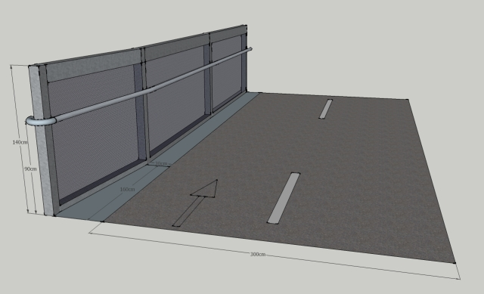
In this example, from Bicycle Network, the fence is 1.4m high with mesh panels between, and flush with, the vertical elements providing a smooth surface that cannot catch or snag a bike or rider.

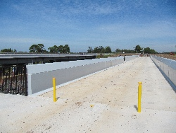
Federation Trail bridge over Werribee River shows clean smooth surfaces and a good safe height of fence. Highly recommended. If on a slope a hand rail would be required and in fitting this, the support brackets should be horizontal to avoid snagging of handlebars.

- East Side
  - East Side - Lagoon Drive to Park Drive
The proposed cross section for the east side is acceptable given that cyclists are travelling uphill and will be going much slower than on the west side. The width is also greater than on the west side. We have the following recommendations to improve the east side:
    - Grass or concrete buffer - Where there is sufficient width, a grass or concrete buffer at least 1.0m wide is preferable to a fence. The path should be built at road level or lower with the path sloping away from the roadway. The buffer and the slope should be very effective at preventing cyclists from falling or rolling onto the roadway. Where a 1.0m buffer is not possible, a fence should be included in the design.
    - Single multi-use path - As there appears to be sufficient space, the preferred design would be a single multi-use path at least 3.5m on the park side of the lamp/signposts. Existing path could be restored to green space.
    - Grade - Grade should be kept consistent and could be slightly reduced in some sections.
    - Avoid poles in the middle of the path - Where possible, the path should be placed on the park side of the poles to avoid poles in the middle of the path

  - East Side - Park Drive to Lions Gate Bridge
    - Add fencing
    - Remove obstacles
    - Widen where possible

- Other Recommendations
    - Improved the underpass at the south end of Lions Gate Bridge - Improve the underpass at the south end of Lions Gate Bridge (lesser grades, better lighting) and/or provide access to east side via overpass at south end of Lions Gate Bridge. This will encourage cyclists to use the correct path and may encourage pedestrians to use the east sidewalk. This should be done before the upgrading of the Causeway as it will enable more effective detours.
    - Improved safety at intersections with causeway - Intersections should be re-aligned for better visibility. The path should be raised through intersections and marked in green with zebra stripes and elephant feet. Cycling should be allowed through the intersections. Drivers on exit/entrance ramps should be required to yield to those on bikes and on foot. The Stanley Park Cycling Plan (http://vancouver.ca/files/cov/stanley-park-cycling-plan-final.pdf) has a similar suggestion on Page 18. Below is their image:

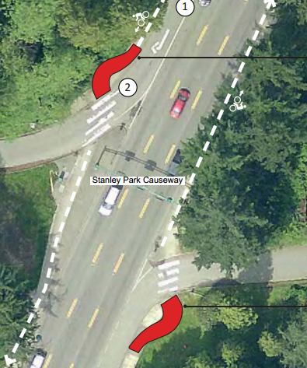
The recommendation is to create “Jug Handles”, though maybe larger than the ones in the picture. The objective is to create a perpendicular intersection. Perhaps road radius could be decreased as well. By raising the path, it is more obvious that path traffic has right of way over road traffic and will also encourage motor vehicles to slow down. Covering the raised path with the green colourized asphalt and adding elephant feet, zebra stripes and yield signs and yield markings on the pavement would make the intersections perfect.

    - Improved lighting - Improve lighting of path, especially at intersections with roadways and park trails.
    - Smooth surface - Build the paths with smooth permeable pavement or sawcut concrete (no expansion joints).
    - Improved pedestrian wayfinding - Improve pedestrian wayfinding signage, including signage pointing to the east side of the causeway and signage to downtown Vancouver. Include distance markings that tell the distance and average time to walk to the destinations. This may deter people from walking the causeway as the destinations are too far. Make it clear how pedestrians can cross over to the other side of the causeway.
    - Close or reroute ad hoc trails that lead to the causeway - Trails should be closed or rerouted especially if there is poor visibility to prevent collisions between cyclists and pedestrians.

Conclusion
We hope that our feedback will be helpful in the design process for safer pedestrian and cycling paths along the Stanley Park Causeway and we look forward to working with MoTI and Vancouver Board of Parks and Recreation to continue to improve the design.

Sincerely,

Arno Schortinghuis Antje Wahl
Director Chair, North Shore Committee
HUB: Your Cycling Connection HUB: Your Cycling Connection
arno@telus.net northshore@bikehub.ca
604 779 0471

