November 12, 2013

City of North Vancouver
Attn: Daniel Watson, Transportation Planner
141 West 14th Street
North Vancouver, BC
V7M 1H9

Dear Daniel,

Over the last two months and at our recent HUB North Shore meeting, HUB members have put together a list of ‘small fixes with big impact’ in terms of making cycling easier and safer in the City of North Vancouver.

The list includes signage, roadway painting, infrastructure improvements and an ‘other’ category. All tolled we came up with 45 different small projects with lesser price tags.

Thank-you for requesting this information. We hope it will help the City to identify projects which will improve conditions for people travelling by bicycle through the City. If you have any questions about the list or would like it ordered in a different way, let me know.

Best Regards,

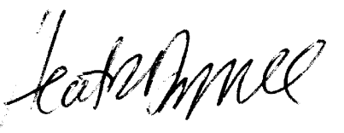
Heather Drugge
Member, HUB North Shore Committee

Heather Drugge
203 1610 Chesterfield Ave
North Vancouver, BC
V7M 2N7
604-868-1309
hdrugge@gmail.com

